Alg 4 Summer Name: ____________________________

______________ _____________

WS Assessment

Target 6:

Basic trigonometry

**I can:**

* Identify and Calculate the basic trig functions: Sine, Cosine, Tangent, Cosecant, Secant, Cotangent
* Using Calculator to find side length and angle value in right triangle

**Unit 8: Trigonometry Function**

* [**HSF.TF.A.2**](http://www.corestandards.org/Math/Content/HSF/TF/A/2/): Explain how the unit circle in the coordinate plane enables the extension of trigonometric functions to all real numbers, interpreted as radian measures of angles traversed counterclockwise around the unit circle.
* [**HSF.TF.B.5**](http://www.corestandards.org/Math/Content/HSF/TF/B/5/): Choose trigonometric functions to model periodic phenomena with specified amplitude, frequency, and midline.*
* [**HSF.IF.C.7.E**](http://www.corestandards.org/Math/Content/HSF/IF/C/7/e/): Graph ~~exponential and logarithmic functions, showing intercepts and end behavior, and~~ trigonometric functions, showing period, midline, and amplitude.

Naming triangle (vertices, side, hyp-opp-adj)

Explain the meaning of $S \begin{matrix}o \\ h\end{matrix} C\begin{matrix} a \\ h\end{matrix} T \begin{matrix}o \\ a\end{matrix}$

Write the values of sin(α), cos(α), sin(β), and tan(β) for the triangle below in fraction

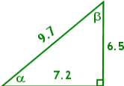

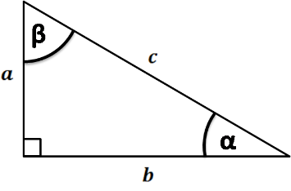

Prove that sin2(+cos2( Prove that sin2(+cos2(

Now we have the first Pythagorean Identities

***sin2(x) + cos2(x) = 1*** For x is any value of angle

Change your calculator mode to DEGREE and find the following, write 4 decimal numbers

sin(76) = ? ___________ cos(31) = ? ___________ tan(16) = ? __________

sin(60) = ? ___________ cos (60) = ? ___________tan (45) = ? __________

In the triangle shown below, find the unknown value, accurate to three decimal places.

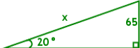 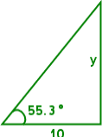

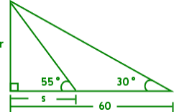Find the angles and sides indicated by the letters in the diagram. Give each answer correct to the nearest whole number.

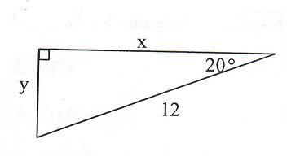Find the unknown values

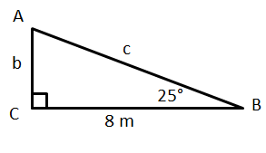

An isosceles right triangle has a hypotenuse

that is 10 units long. About how long are its legs.

Sketch the picture

The stairs of the Kukulcan Pyramid at a 48 degree angle. When you get to the top, you are 100 feet above the ground (about ten stories). How long is the stairway? Sketch the picture.

Rigo is holding his kit spool about 3 feet off the ground. The kite is flying at 55 degree angle with the horizontal. The kite is directly over his friend Milo's head. If Milo is about 50 feet from Rigo, how high is the kite? Sketch the picture.

|  |  |  |
| --- | --- | --- |
| Cosecant is the reciprocal of sine | Secant is the reciprocal of cosine | Cotangent is the reciprocal of tangent. |
|  |  |  |

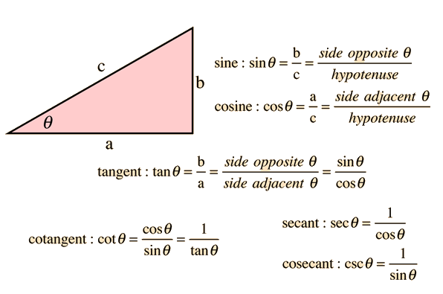In each triangle ABC, angle C is a right angle. Find the value of the trig function indicated (Sketch if needed)

a. Find cos A if b = 24, a = 7 b. Find cot A if c = 25, b = 20

c. Find sin A if c = 10, b = 8 d. Find sec A if b = 23, a = 23

e. Find tan A if c = 15, a = 3 f. Find csc A if b = 4 , c = 5

g. Find cot A if a = 15, b = 8 h. Find sin A if a = 16, b = 12

i. Find sin θ if cot θ = 4/3 j. Find tan θ if sec θ = 13/12

k. Find cos θ if sec θ = 7/3 l. Find csc θ if cos θ = 15/17

m. Find sin θ if cos θ = 5/19 n. Find cos θ if tan θ = 4/3

p. Find cos θ if sin θ = 10/11 q. Find csc θ if sec θ = 5/3

The trig inverse function will undo the calculation and return the angle in degree

sin-1( .70711) =? _____ cos-1(.5) = tan-1(2.7475)=

cos-1(.25882) = tan-1(.46631) = sin-1(.96593) =

Use the inverse trigonometry to find the value of angle (round to 1 decimal)

tan X = 0.3057 sin B = 0.4384

cos W = 0.3420 sin V = 1.2541

Find the value of the angle

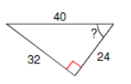 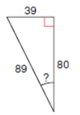

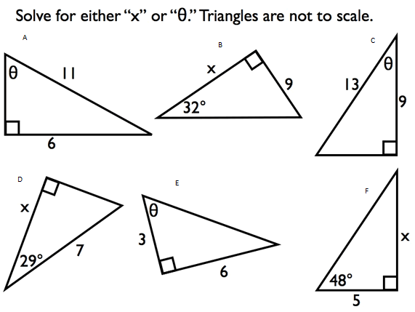

$θ=$

1. x =
$θ=$

2. x =
$θ=$

3. x =

**Assessment Target 6**

**I can** … Solve the basic trigonometry

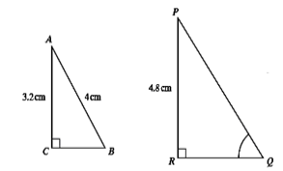Given triangles ABC and PQR are similar. AC = 3.2 cm, AB = 4 cm and PR = 4.8 cm.

Find the length of side PQ and RQ

Using triangle PRQ, write the value of all **six** trig functions of angle Q in fraction form

Find the side length of BC and AC Find the degree of angle P and angle R

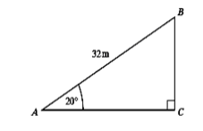 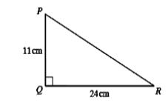

Find angle D Prove the identity for angle A

